

**AXIUM REMOTE ACCESS INSTRUCTIONS**

**Please read the following instructions on how to connect to remote Axium outside of UB,**

**Note: you will not need to do this if you are using on campus wifi.**

**Fortinet VPN:**

***The VPN client can be downloaded here***:

**MacOS:** <http://www.buffalo.edu/ubit/service-guides/software/downloading/macintosh-software/managing-mac-software/fortinet.html>

**Windows:** <http://www.buffalo.edu/ubit/service-guides/software/downloading/windows-software/managing-your-software/fortinet.html>

**To configure the Fortinet client:**

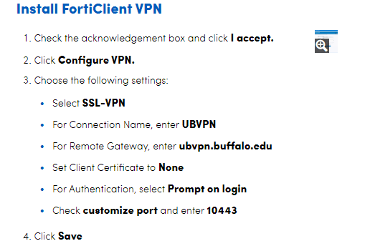

* To Connect, please note, you will need your Duo token set up at this point.

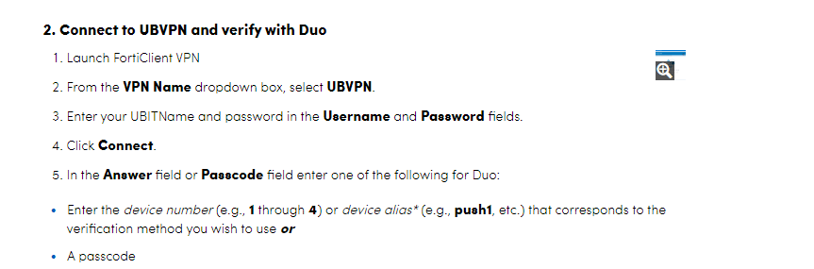

**If you are running High Sierra MacOS:**

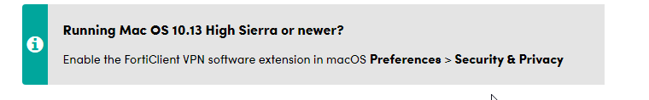

**Citrix Workspace:**

It is a good idea to update to the latest version of citrix workspace. It’s best to uninstall the old version before installing the new one. The new Mac client comes with an uninstall program, run that first.

**The latest version can be downloaded here:**

**Windows** - <https://www.citrix.com/downloads/workspace-app/windows/workspace-app-for-windows-latest.html>

**Mac** - <https://www.citrix.com/downloads/workspace-app/mac/workspace-app-for-mac-latest.html>

**Citrix Web Portal:**

If you citrix client (Receiver/Workspace) has been configured to access the remote site directly it will no longer work.

* You will need to use the remote web portal <https://citrixremote.sdm.buffalo.edu> in your web browser.
* After logging in, click detect receiver if it pops up.

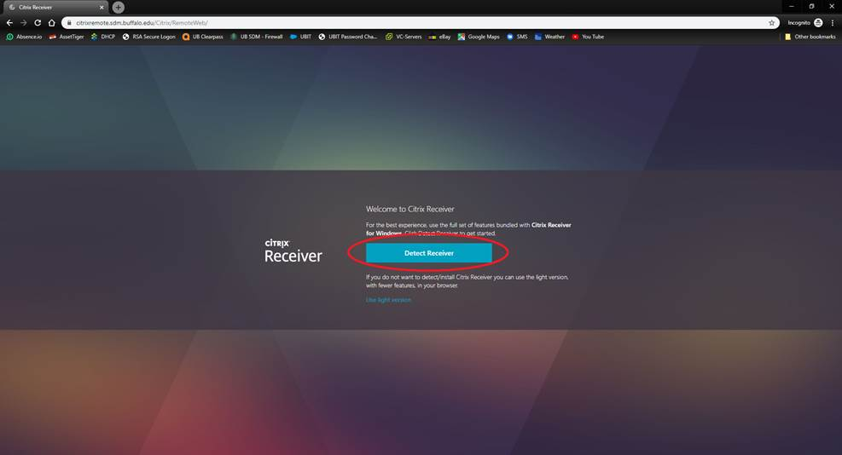

* At the detecting receiver page you do not need to click download.
* The software was already installed in a previous step. Just click “Already installed”.

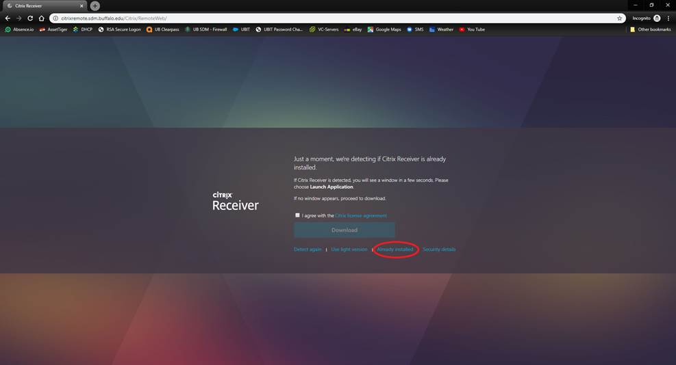

* Click the axium icon and open the file that is downloaded to your computer to launch Axium.

If you are continuing to have issues, please contact the UB SDM Helpdesk at either 716-829-2056 or email [sdmhelp@buffalo.edu](mailto:sdmhelp@buffalo.edu)